**CalculatingFamilyExpensesusingServiceNow** **Team Id :NM2025TMID17228**

**TeamMembers:04**

**TeamLeader:** SANGEETHA.S (05.02.2006)

**TeamMember1:** **RUBAVATHY.S**

**Team Member2:** **SANGEETHA.S (29.10.2005**

**Team Member 3:** **SWETHA B**

**Team member 4:** **SUBASRI M**

**Problem Statement:**

**Familiesfacedifficultyinmanagingandtrackingtheir monthly expenses.**

**Thereisnopropersystemtorecordandcategorize spending.**

**Thisleadstopoorfinancialplanningandlackofclarity in savings.**

**AServiceNowappisneededtocalculate,analyze,and report expenses.**

**Objective:**

**TodevelopaServiceNow-basedapplicationthathelps families record, categorize, and calculate their expenses, and provides reports for better financial planning and analysis.**

**Skills:**

**ServiceNowPlatformKnowledge–Tables,Forms, Lists, Modules**

**ApplicationDevelopmentinServiceNow –Creating custom apps**

**Scripting–ClientScript,BusinessRule,ScriptInclude (JavaScript)**

**Workflow/FlowDesigner–Automatingexpense approvals or reports**

**Reporting&Dashboards–Charts,graphicalreports for expenses**

**BasicDatabaseKnowledge–Storingandretrieving expense records**

**AnalyticalSkills–Categorizingandanalyzingexpenses**

**TASKINITIATION**

Milestone1:**SettingupServiceNow Instance**

**Milestone1:SettingupServiceNowInstance** **Activity 1:Setting up ServiceNow Instance**

1. Signupforadeveloperaccount ontheServiceNowDevelopersite

“https://developer.servicenow.com”.

1. Onceloggedin,navigatetothe"PersonalDeveloperInstance" section.
2. Clickon"Request Instance"tocreateanewServiceNowinstance.
3. Fillout therequiredinformationandsubmit therequest.
4. You'llreceive anemailwiththeinstancedetailsonceit's ready.
5. LogintoyourServiceNowinstanceusingtheprovidedcredentials.
6. Nowyouwillnavigatetothe ServiceNow.

**Milestone2:CreationofNewUpdateSet Activity 1:Creation of New Update Set**

1. GotoAll>>InthefiltersearchforLocalUpdateset>clickonNew.

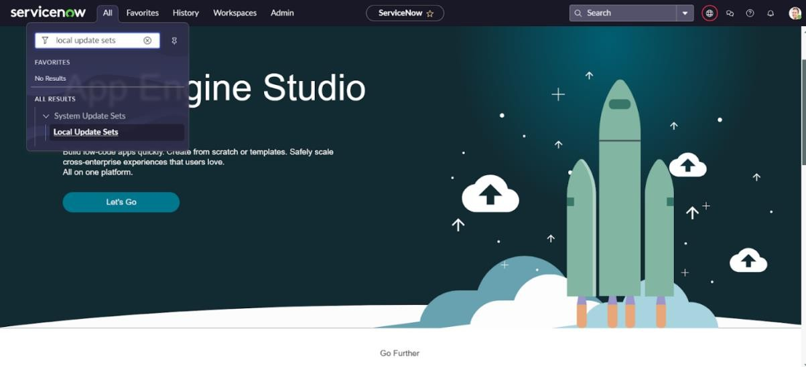

1. Enter the Details as: Name:FamilyExpenses
2. ThenclickonSubmit andMakecurrent.

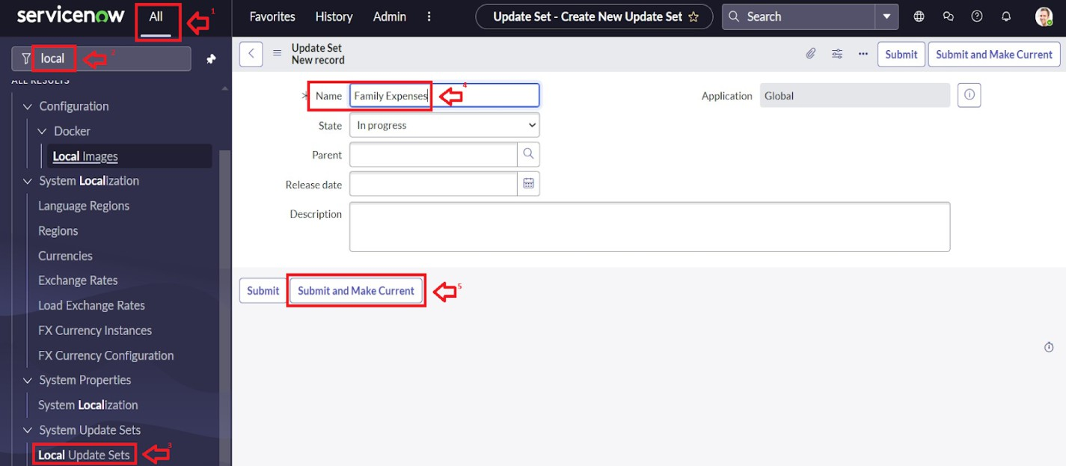

**Milestone 3:Creation of Table****Activity1:CreationofNewUpdateSet**

* 1. GotoAll>>InthefiltersearchforLocalUpdateset>clickonNew.



* 1. Enter the Details as: Name:FamilyExpenses
  2. ThenclickonSubmitandMakecurrent.



**Milestone4:CreationofTable**

**Activity1:CreationofFamilyExpenses Table**

* + 1. GotoAll>InthefiltersearchforTables>clickonNew.
    2. EntertheDetails:

Label:FamilyExpenses Name : Auto-Populated

Newmenuname: Family Expenditure

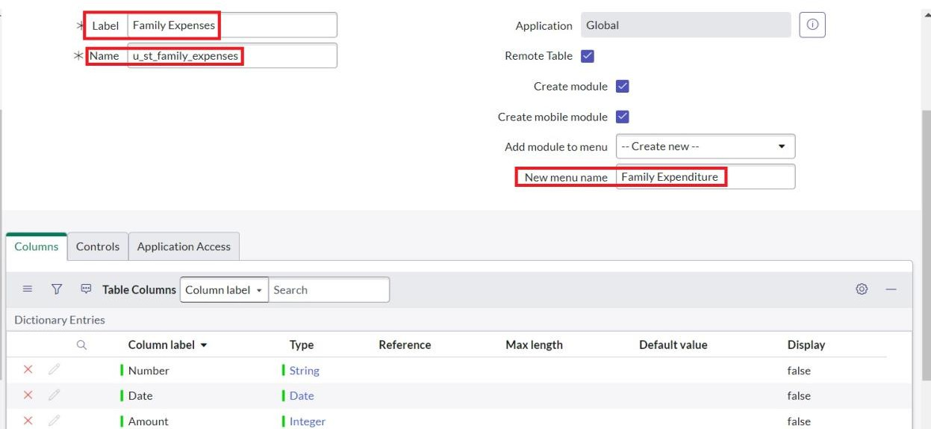

* + 1. GototheHeaderandright clickthere>> clickonSave.

**Activity2:CreationofColumns(Fields)**

* + - 1. NearColumnsDoubleclicknearinsert anew row.
      2. Givethedetailsas:

Columnlabel:Number Type : String

* + - 1. Doubleclickoninsert anewrowagain
      2. Give the details as:Columnlabel:Date Type : Date
      3. Doubleclickoninsert anewrowagain
      4. Givethedetailsas:

Columnlabel:Amount Type : Integer

* + - 1. Doubleclickoninsert anewrowagain
      2. Givethedetailsas:

Columnlabel:ExpenseDetails Type : String

Maxlength: 800

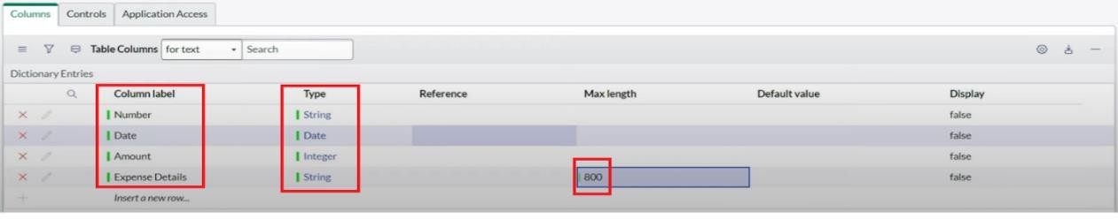

* + - 1. GototheHeaderandright clickthere>> clickonSave.

**Activity3:MakingNumberFieldanAuto-Number**

* + - * 1. DoubleclickontheNumberField/Column.
        2. GodownanddoubleclickonAdvancedview
        3. InDefaultValue:

Usedynamicdefault : checkthebox

Dynamicdefaultvalue:GetNextPaddedNumber

* + - * 1. ClickonUpdate. 5.

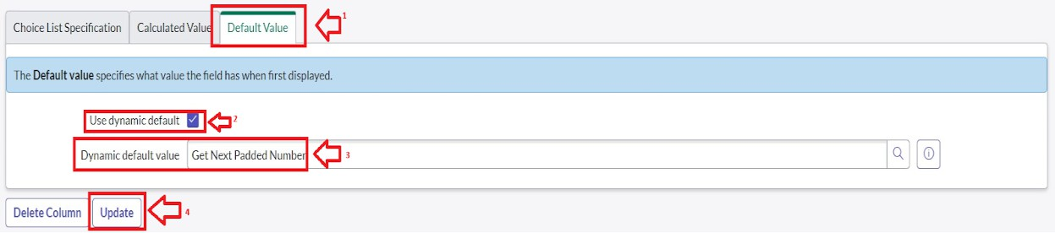

1. GotoAll>>InthefiltersearchforNumberMaintenance>>select Number Maintenance
2. Clickon New.
3. EnterthebelowDetails: Table: FamilyExpenses Prefix : MFE

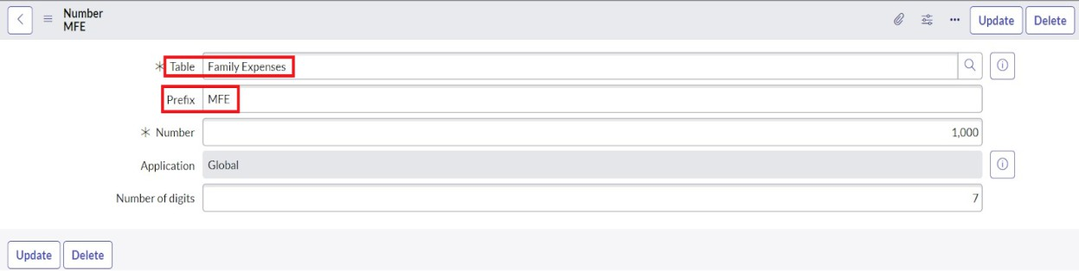

1. ClickonSubmit.

**Activity4:Configurethe Form**

* 1. GotoAll>>InthefiltersearchforFamilyExpenses>>OpenFamilyExpenses
  2. ClickonNew
  3. GototheHeaderandright clickthere>> clickonConfigure>> Select FormDesign
  4. 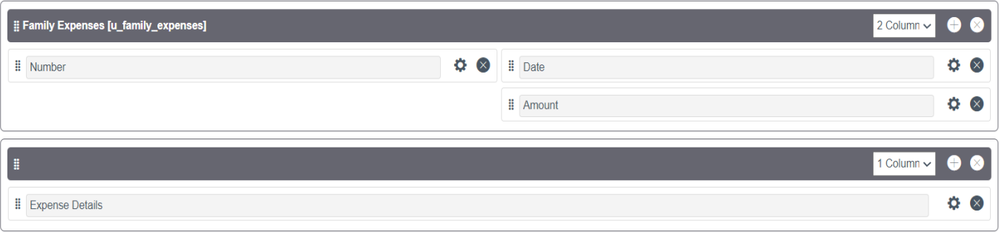CustomizeorDragDroptheformasperyourrequirement.
  5. MakeNumberRead-OnlyFieldbyclickingonthegeariconandcheckingRead-Only
  6. MakeDate,AmountMandatoryFieldbyclickingonthe geariconandchecking Mandatory
  7. ClickonSave.

**Milestone5:CreationofTable(DailyExpenses)** **Activity 1:Creation of Daily Expenses Table**

* + 1. GotoAll>InthefiltersearchforTables>clickonNew.
    2. EntertheDetails:

Label:DailyExpenses

Name:Auto-Populated

AddModuletomenu:FamilyExpenditure

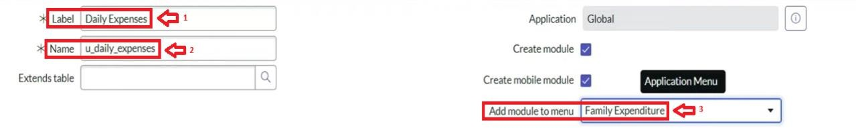

* + 1. GototheHeaderandright clickthere>> clickonSave.

**Activity2:CreationofColumns(Fields)**

* + - 1. NearColumnsDoubleclicknearinsert anew row.
      2. Givethedetailsas:

Columnlabel:Number Type : String

* + - 1. Doubleclickoninsert anewrowagain
      2. Give the details as:Columnlabel:Date Type : Date
      3. Doubleclickoninsert anewrowagain
      4. Givethedetailsas:

Columnlabel:Expense Type : Integer

* + - 1. Doubleclickoninsert anewrowagain
      2. Givethedetailsas:

Columnlabel:FamilyMemberName Type : Reference

Maxlength: 800

* + - 1. Doubleclickoninsert anewrow again
      2. Givethedetailsas:

Columnlabel:Comments Type : String

Maxlength: 800

* + - 1. GototheHeaderandright clickthere>> clickonSave.

**Activity3:MakingNumberFieldanAuto-Number**

* + - * 1. DoubleclickontheNumberField/Column.
        2. GodownanddoubleclickonAdvancedview
        3. InDefaultValue:

Usedynamicdefault : checkthebox

Dynamicdefaultvalue:GetNextPaddedNumber

* + 1. ClickonUpdate.



* + 1. GotoAll>>InthefiltersearchforNumberMaintenance>>select NumberMaintenance
    2. Clickon New.
    3. Enter the below Details: Table:FamilyExpenses Prefix : MFE

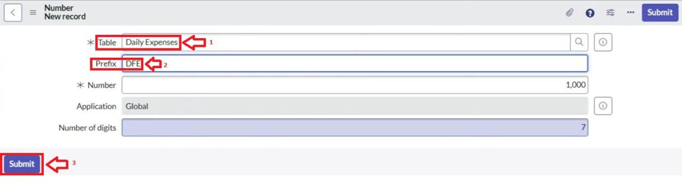

* + 1. ClickonSubmit.

**Activity4:Configurethe Form**

* + - 1. GotoAll>>InthefiltersearchforDailyExpenses>>OpenDailyExpenses
      2. ClickonNew
      3. GototheHeaderandright clickthere>>clickonConfigure>>Select FormDesign
      4. CustomizeorDragDroptheformasperyourrequirement.

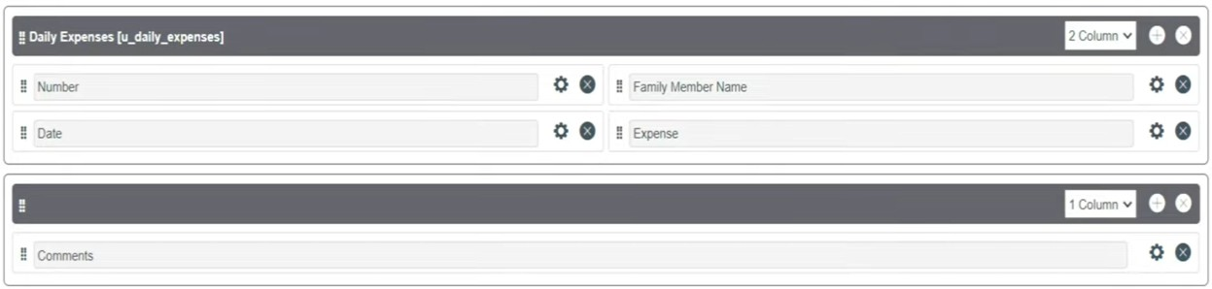

* + - 1. MakeNumberRead-OnlyFieldbyclickingonthegeariconandcheckingRead-Only
      2. MakeDate,FamilyMemberNameMandatoryFieldby clickingonthegeariconand checking Mandatory
      3. ClickonSave.

**Milestone6:CreationofRelationship**

**Activity1:CreationofRelationshipbetweenFamily Expenses and Daily Expenses tables**

* + - * 1. GotoAll>>InthefiltersearchforRelationships>>OpenRelationships
        2. Clickon New.
        3. Enter the details:Name:DailyExpenses

Appliestotable:SelectFamilyExpenses Daily Expenses : Select Daily Expenses

* + 1. ClickSave.

**Milestone7:ConfiguringRelatedListonFamily Expenses**

**Activity1:ConfiguringRelatedListonFamily Expenses**

* + - 1. GotoAll>>InthefiltersearchforFamilyExpenses>> OpenFamilyExpenses
      2. ClickonNew
      3. GototheHeaderandright clickthere>> clickonConfigure>> Select RelatedLists
      4. AddDailyExpensestotheSelectedArea.
      5. Clickon Save

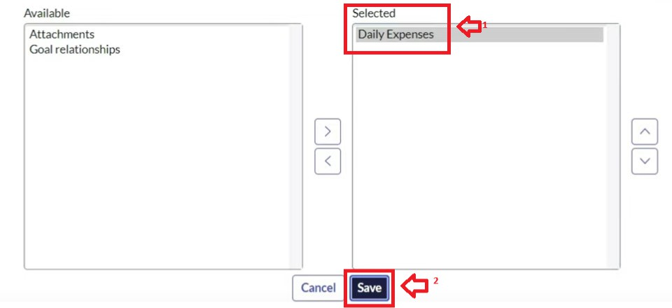

**Milestone8:CreationofBusinessRules** **Activity 1:Creation of Business Rules**

1. GotoAll>>InthefiltersearchforBusinessRules.
2. UnderSystemDefinitionSelect BusinessRulesthenclickon New.
3. EntertheDetails:

Name : Family Expenses BR Table:SelectDailyExpenses Check Advanced

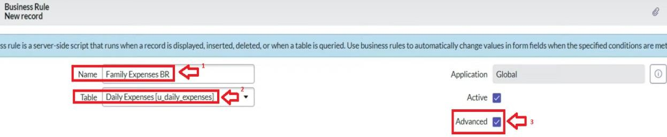

* 1. InwhentorunCheckInsertandUpdate

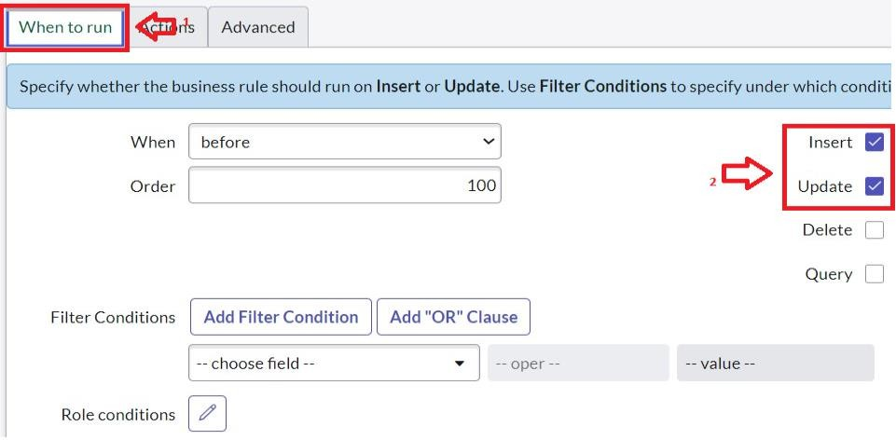

* 1. In Advance(we write the code): Write the below code >> (functionexecuteRule(current,previous/*nullwhenasync*/){

varFamilyExpenses=newGlideRecord('u_family_expenses'); FamilyExpenses.addQuery('u_date',current.u_date); FamilyExpenses.query();

if(FamilyExpenses.next())

{

FamilyExpenses.u_amount += current.u_expense; FamilyExpenses.u_expense_details += ">"+current.u_comments+":"+"Rs."+current.u_expense+"/-"; FamilyExpenses.update();

}

else

{

varNewFamilyExpenses=newGlideRecord('u_family_expenses'); NewFamilyExpenses.u_date = current.u_date; NewFamilyExpenses.u_amount = current.u_expense; NewFamilyExpenses.u_expense_details += ">"+current.u_comments+":"+"Rs."+current.u_expense+"/-"; NewFamilyExpenses.insert();

}

})(current,previous);

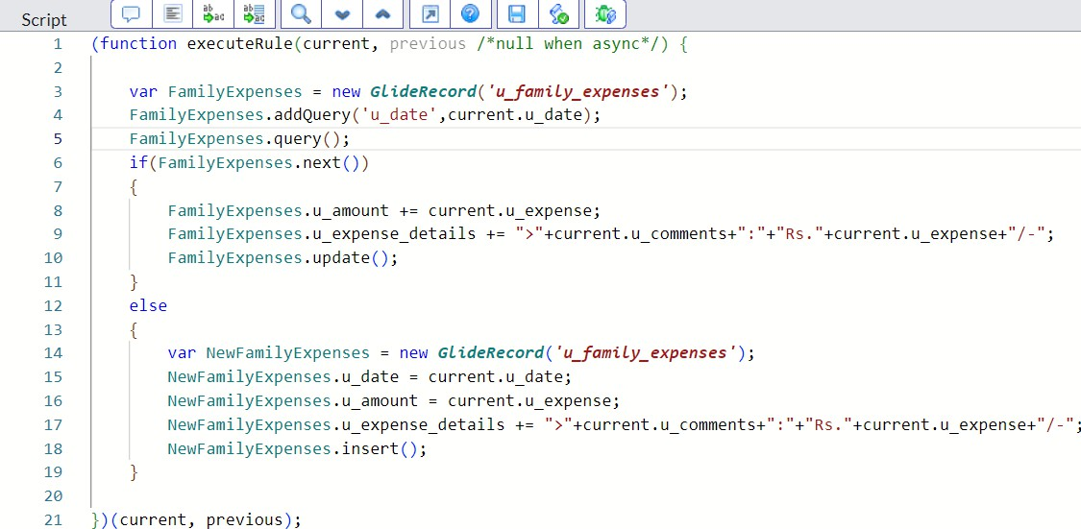

* 1. GototheHeaderandright clickthere>> clickonSave.

**Milestone9:ConfiguretheRelationship**

**Activity1:ConfiguretheRelationship**

* + 1. GotoAll>>InthefiltersearchforRelationships>>OpenRelationships.
    2. Inthat, openDailyExpenses Relationship.
    3. ForAppliestotable: SelectFamily Expenses.
    4. InQuerywith: writethebelow Query.

(functionrefineQuery(current,parent){

//Addyourcodehere,suchascurrent.addQuery(field, value); current.addQuery('u_date',parent.u_date);

current.query();

})(current,parent);

* + 1. ClickonUpdate.

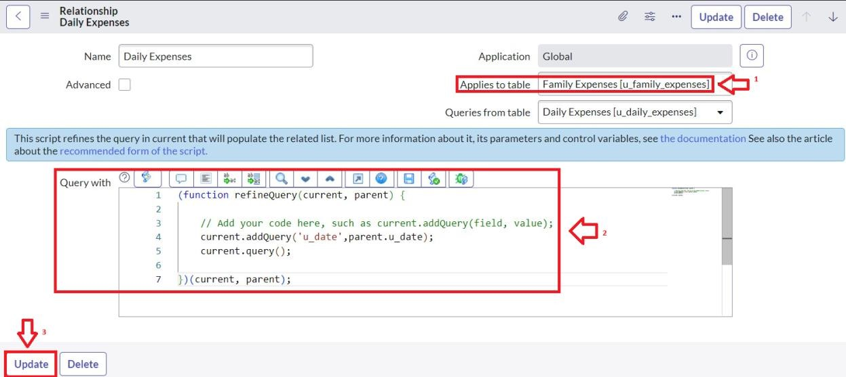

**Conclusion**